Custom Commitments Training Guide

Table of Contents
I. Overview
II. Create a new commitment
III. Spreading Commitments Over Multiple Months
IV. Create a new commitment by copying an existing commitment
V. Searching for Existing Custom Commitment
VI. Updating an existing commitment
VII. Data Entry screen basics
VIII. Buttons
IX. Field Definitions
X. Searching for Expenditure Type, VIP, or Project / Task / Award / Organization string
XI. Additional Help
I. Overview
As a tool to enhance financial reporting, Custom Commitments provides departments the ability to create and maintain records about outstanding financial commitments and projections that are not captured by other systems. The three types of custom commitments that can be generated are Labor, Revenue and non-labor Expense. Custom Commitments appear on standard fixed format reports (e.g., Account Holder Report, Commitment Detail) available from the Data Warehouse.
After you create new Custom Commitments or update/expire existing ones, you may return to the main menu and submit them for direct update to the Data Warehouse. The commitments will become available for reporting within about ten minutes of submission to the Data Warehouse. If you do not submit commitments to the Data Warehouse yourself, a nightly job will update Custom Commitments in the Data Warehouse and become available for reporting the next day.
Top of screen
II. Create a new commitment
- From the main menu choose Custom Commitments, and then select Yale Custom Commitments to start.
- Choose a commitment type (Expense, Labor, Revenue) and click the Create button. A new record number will appear on the form.
- Enter data to capture details about the commitment.
  - All fields marked with * are required;
  - All fields in regular font are optional. All fields in italics are system-generated and cannot be changed manually; Field definitions are available in Section IX.
    - Click Submit/Save to save the commitment. Once saved, Status at the bottom of the screen becomes Active, the Created By field is populated with your NetID, and the Creation Date is populated with the current date. The confirmation message appears at the top left side of the screen.
    - To create another commitment with the same commitment type click the Create button. To create different type of commitment repeat steps 2 through 3.
A completed Custom Commitment entry screen is as follows:
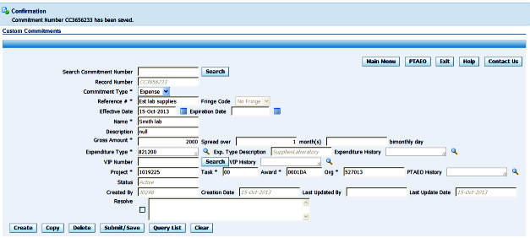
Top of screen
III. Spreading Commitments Over Multiple Months
A single commitment can be created that will be spread over several months. When it is spread, a part of the commitment will expire at the end of each month. For example, a $10,000 commitment spread over 5 months will result in $2,000 of the commitment expiring each month. When you create a commitment that will be spread over several months, the application will explode or burst the commitment for you into multiple records.
To create an exploded commitment, set the total amount of the commitment in the Gross Amount field. Set the total number of months over which the commitment will be spread in the spread over _________ month’s field. (To start a commitment in the future, set the start date of the commitment in the Effective Date field.)
When you Submit/Save the commitment, a window like the one shown below will open showing the commitment exploded into several commitments. Each month's commitment will be separated onto a new commitment record. The first month will retain the original commitment number, and the new commitments will be assigned new commitment numbers. The transaction control number (or document number or order number) will append a two-digit number that is different for each month (e.g., 1234 will turn into 1234-01, 1234-02, etc.). The dollar amount will be split evenly over the months. Each commitment will expire on the last day of the month. You have the option to edit the dollar amount of each commitment.
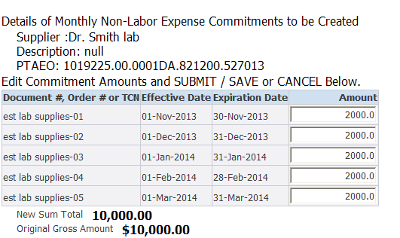
After you Submit the commitments, you will see a confirmation screen like the one below that provides key commitment information, including the new commitment numbers, their expiration dates, and amounts. For your convenience, a Print button is available at the bottom of the confirmation window. Otherwise, you can click the “Back/Main Page” button to return to the Custom Commitment entry screen.
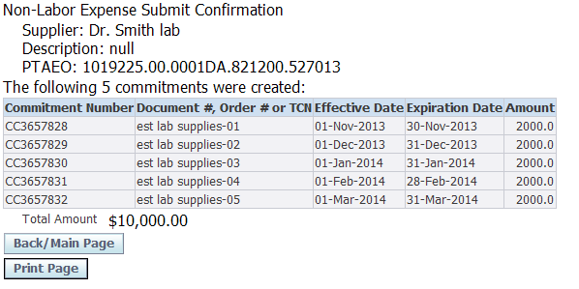
NOTE: If you have a commitment of a negative dollar amount that you want to spread over multiple months, you will need to initially enter a positive amount. After you Submit and see the list of detailed commitments, you can add the negative to each individual commitment.
Top of screen
IV. Create a new commitment by copying an existing commitment
- Open an existing commitment by using either the Search or the Query List button (instructions Section V.)
- Click the Copy button. You will receive a confirmation message that "Your previous commitment has been copied to Commitment Number" “New Number”. You may now proceed.
- All data from the original commitment is preserved on the copy except:
  - a new record number (e.g., CC1004567) is assigned;
  - the Reference # field is blank; and
  - Effective Date defaults to the current date.
- Edit the new commitment as needed.
- Submit/Save the commitment.
Top of screen
V. Searching for Existing Custom Commitment
Existing custom commitments may be retrieved for update by using either the Search button at the top of the form or Query List buttons at the bottom of the screen.
Search button: Type the specific record number (e.g., CC1004321) of the commitment you want to retrieve and click Search.
Query List button: Allows you to search for a record to edit by specifying up to five criteria. To enter search criteria:
- Specify the field name (e.g., Name, Reference #, Creation Date) on which to base your search by using the pull-down menu. Choose up to five criteria on which to pull your data. All field names are searchable and are defined in Section IX.
- Select the operator (e.g., is, contains) by using the pull down menu in the second field.
- Enter the characters on which to base your search in the third field.
- Click the Search button.
You may enter single or multiple criteria. If you enter multiple criteria,
only records that meet all criteria will be returned.
Example: Commitment Type contains Revenue
Description contains Misc
In the above example, all records that have a Commitment Type of Revenue and
a description of Misc Revenue will be retrieved.
- All records that match the criteria will appear in a list. To select a record to edit, click the underlined Record Number.
In addition to the five criteria you can set using the parameter fields, there are two optional parameters available to use in searching.
  - Effective Date is between: Set begin and end dates in the two available fields. All records that meet all other parameters and that have an Effective Date between these dates, inclusive, will return.
  - You may also specify additional record selection criteria: Select a choice to limit records returned to active commitments or all commitments, including active, expired and resolved records.
Note that you may only view and edit records that you created or for which you have the appropriate Yale Authorization Subsystem (YAS) authority. For example, if you have the YAS authority to view/edit records for organization 720400, you may edit any record that you've created or any record that was created by anyone for organization 720400.
Top of screen
VI. Updating an existing commitment (single or mass commitment changes)
Changing a single commitment (when changing more than just the $ amount).
Select a commitment to edit. Once the selected record is opened, edit the data as needed and then click the Submit/Save button. Once saved, the Last Updated By field is updated with your NetID and the Last Update Date is updated with the current date.
Changing the Amount of one or more commitments can now be made on the Query Results screen. Enter the new amount for one or more commitments in the New Amount column. You do not have to check boxes. Click the Save Updated button. A screen confirming your change will appear like the one below.
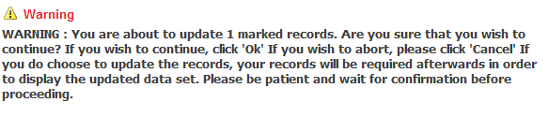
Click OK (on the right side of the screen) to confirm or click Cancel to abort the updates. Click OK. Note that the Record Update Confirmation Screen will provide you a list of all commitments changed by you, query list screen is refreshed and the records are now updated. At this point you can:
- Choose Search and you are directed to the Query Screen for a new query
OR
- Choose Custom Commitments and you are directed to the main Custom Commitments screen
Deleting Commitments can be made on the Query Results screen. Check the boxes for all commitments that you want to delete. Click the Delete Checked button. A screen confirming your deletion like the one below will appear.
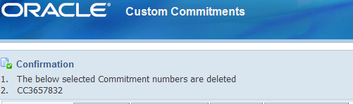
Click OK. Note that the Delete Confirmation Screen will provide you a list of all commitments deleted by you, query list screen is refreshed and the deleted records are now removed. At this point you can:
- Choose Search and you are directed to the Query Screen for a new query
OR
- Choose Custom Commitments and you are directed to the main Custom Commitments screen

Top of screen
VII. Data Entry Screen Basics
Custom Commitments uses the following conventions to help guide your data entry:
Fonts and * used for each field indicate basic rules:
Fields marked with * indicates data is required.
Normal font indicates data is optional.
Italicized font indicates system generated data that cannot be altered manually.

List of Values (LOV) icons are available for the following fields:
- Expenditure Type: If you know the value, you may key in the 6 digits. Otherwise, click the LOV icon to search for the Expenditure Type. You may search by various attributes (e.g., Expenditure Type starts with 82; Expenditure Description contains Film). The associated Description will automatically populate if selected from the LOV, but it will not appear until the record is saved when the expenditure type is keyed in.
- VIP Number: To speed data entry, you may key in a VIP Number (e.g., VIP1234567) to generate its associated Project, Task, Award, and Organization (PTAO). Once populated, you cannot change the PTAO unless you delete the VIP. You may use the VIP Number feature for any type of commitment (i.e., it is not limited to VIP Phone Orders).
For Expenditure Type, VIP Number, and PTAO combinations, you may click the LOV icon next to their history fields i.e. Expenditure History and PTAO History to open a list of previous values that you've used. LOV displays the last 25 distinct values used for the field. Click the Quick Select icon next to the value to select it.
Top of screen
VIII. Functions and Buttons
Home | Return to the main menu page.
Log Out | Closes Custom Commitments and brings you back to the sign-in page. When ending your session, always click Exit to log out rather than navigating to another web site or closing your browser. Otherwise, the application will not recognize that you've exited, risking potential problems.
 | Opens a new window containing the PTAEO Validator.
 | Opens the Help window.
 | Opens a window giving information on contacting DW User Support and the Help Desk.
 | Creates a new custom commitment and issues a new record number.
 | Copies the current commitment into a new commitment, and issues a new record number.
Resolve | This check box resolves the commitment that is open on the screen. When the commitment is resolved, it is no longer active and will not show on future reports. Its history will be saved in the data warehouse. It  will also be viewable in Custom Commitments  Inquiry.
 | Permanently deletes the current commitment. The commitment will not show on reports and will not be viewable in Custom Commitments Inquiry.
 | Saves the current commitment and makes it active. Saves any changes to existing commitments.
 | Retrieves an existing commitment by record number.
 | Retrieves an existing commitment based on search criteria. See Update an Existing Commitment.
 | Clears the current form. Unsaved data is deleted.

Top of Screen
IX. Field definitions
The following fields are available on the Custom Commitments window.
Search Commitment Number: Search for an existing commitment
Record Number: System-generated Custom Commitment number.
Commitment Type: Choose the type of commitment you wish to create: Revenue, Labor, Non-labor from drop down menu.
Reference#: Reference number associated with this record: Labor - Employee's assignment number if known; job title or other reference note if Assignment number is unknown, Revenue- Reference# associated with this record, Expense-Reference# associated with this record or other identifying number.
Fringe Code: Only available for Labor commitments.
Employee's fringe benefit type. Allows appropriate fringe benefit amount to be added to the commitment. Types are: No fringe, Hourly, Part-time, Salary. Percentages are available on the Blue Pages.
Effective Date: Date commitment goes into effect. Defaults to the current date but can be changed to any date.
Expiration Date: Last date commitment is active. Automatically expires the commitment after the specified date. Enables you to avoid manually relieving the commitment in the future. Enter only if the commitment will not be spread over multiple months (turned into several commitments, each of which expires on a separate month).
Name: Employee's name or job title, if name is unknown.
Description: Text field for entering an appropriate description.
Gross Amount: Total Dollar amount of commitment
- Revenue: Enter value as a positive amount; it will appear as a credit in Data Warehouse Reports
- Labor: Enter salary amount only as fringe will be automatically generated.
- Expense: Enter total amount of expense.
Spread over_________ month(s): Entering a number other than 1 (one) in this field will result in an explosion (see below for details) in which the commitment is turned into several commitments, each of which expires on a separate month.
Expenditure Type: Expenditure type for this transaction. See Section V for searching directions. For more information on ET's please click here
Exp. Type Description: Description of expenditure type. Will fill in immediately when expenditure type is selected from the List of Values; will fill in when commitment is Submitted/Saved if typed in manually. See Section VII for searching directions.
VIP Number: 10-character string beginning with VIP (e.g., VIP1239876) that is associated with one Project, Task, Award, Organization (PTAO) string. This is a quick way of entering charging instructions. See Section VII for searching directions.
Project: Part of charging instructions. For more information on the use of 'Project' please click here
Task: Part of charging instructions. For more information on the use of 'TASK' please click here
Award: Part of charging instructions. . For more information on the use of 'Award' please click here
Org: Part of charging instructions. See Section X for history list for PTAO string. For more information on the use of 'Org' please click here
Status: Current status of commitment. Status values for Labor commitments are: Active (current commitment); Resolved (commitment that is closed; history is kept in data warehouse); Expired (current date is after expiration date of commitment). System-generated.
Created By: Net ID of person who created commitment. System-generated.
Creation Date: Date commitment was created. System-generated.
Last Updated By: Net ID of person who last updated commitment. System-generated.
Last Updated Date: Date of last update to commitment. System-generated.
Resolve: Resolves the commitment that is open on the screen. When the commitment is resolved, it is no longer active and will not show on future reports. Its history will be saved in the data warehouse. It will also be viewable in Custom Commitments Inquiry. Top of screen
X. Searching for Expenditure Type, VIP, or Project / Task / Award / Organization string
List of Values
The List of Values button after the Expenditure Type and VIP fields allows you to search for a particular value.
Expenditure Type: Searching parameters available in the first field are:
- Expenditure Type: The Expenditure Type value, e.g., 881300.
- Expenditure Code: The expenditure type and its name, e.g., 881300 EquipFurn U.
- Expenditure Description: The description of the expenditure type, e.g., Furniture Cost $2000 or more.
- Expenditure Category: A general grouping in which the Expenditure Type belongs, e.g., 8810 Equipment Purchases.
- Select the operator (e.g., is, contains, starts with) by using the pull down menu in the second field.
- Enter the characters on which to base your search in the third field.
- Click the Find button.
Expenditure Types
Revenue Commitments: Use expenditure types 470000 to 529999.
Labor Commitments: Use expenditure types 711000 to 813999,
and 833200, 910600, 910610 and 910700.
Expense: Use expenditure types 820100 to 999995.Additional
expenditure types are available for Inventory and Liability accounts.
VIP
Enter the full VIP number (with or without the prefix VIP) to generate the associated PTAO.
History List
For Expenditure Type, VIP Number, and PTAO combinations, you may click the icon next to the field to open a list of previous values that you've used. Each history list displays the last 25 distinct values used for the field. Click the Quick Select icon next to the value to select it.
Top of Screen
XI. Additional Help
For questions or comments about the Custom Commitment Application please send email to dw.usersupport@yale.edu.
If you are experiencing a problem with this application, Please contact the Help Desk at 432-9000.

