**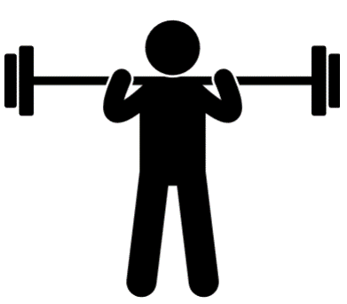  
Battle** **of **the Badges****

When: Saturday, **April 14**, from 9:00 a.m. - noon

A bench press competition to benefit cancer research at Smilow Cancer Hospital   
at Yale New Haven

Where: Payne Whitney Gym

**Israel Fitness Center, 70 Tower Parkway, 4th floor**



Regulations

2 divisions to enter (open to public)

3-person teams

Entry Fee

Collected at the door - cash only please

$20 per person

$15 per student

Sponsored by Yale University Police Department

Rules

Max # of repetitions based upon body weight

Men lift 75% of body weight

Women lift 50% of body weight

Deadline for online registration is Wednesday, April 19th at midnight, visit:

**https://your.yale.edu/community/public-safety/battle-badges-2018**

For more information, contact Captain Von Narcisse • 203-432-4415 • von.narcisse@yale.edu or Sergeant James Scott • 203-627-8194 • james.t.scott323@gmail.com