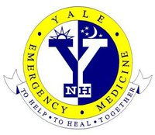

Emergency Medicine Research Approval Form

Instructions: Please click the link below to access our electronic form, which is required for all new human research studies that screen or enroll patients in the Yale Emergency Department OR any studies that require use of Emergency Department resources (i.e., ED office workspace, storage, equipment, etc.). We have also included a preview of the form, to help ensure you have all the required information prepared.

If you have any questions, please contact Bidisha Nath at bidisha.nath@yale.edu or 617-413-8571.

Qualtrics link: https://yalesurvey.ca1.qualtrics.com/jfe/form/SV_55OtN17ebtEDg5U.

