Make-It-So
Make Is So is a standalone application which takes the work you’ve completed in the YBT labor plan and pushes it to Labor Distribution (LD), saving you time and effort, as well as preventing duplication and text entry errors. YBT does not process labor distribution adjustments in this push to LD.
Need Assistance?
If you cannot install or open YBT or Make-It-So, please call the ITS help desk at 203.432.9000.
For questions and issues about specific YBT functions or data:
- Email ybtsupport@yale.edu or
- Call the YBT help desk at 203.436.5929
System documentation and training materials can also be found on the YBT home page, as well as at http://yalebiz.yale.edu/yale-budgeting-tool.

Accessing Make-It-So
- Go to the Yale portal (https://portal.yale.edu).  - Log in to the portal with your Yale NetID and password.  - Click the BMS/Make-It-So link.  - Enter your BMS/Make It So username and Password and click Connect.  - Make-It-So opens to the Employee List screen, as shown below. | 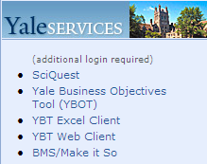

Using Make-It-So
- Make-It-So opens to the Employee List screen. You may use the Workbook Filter to select just one workbook or leave it blank to see everyone within your YBT security access. (The default is to see all employees; however, you can select Show Changed YBT to see only those newly changed in YBT.) | 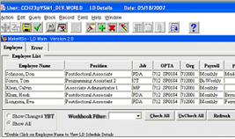
- You may use the Check All button to select all employees. Once checked, you can select Uncheck All and manually check just the employees you want to submit in the column to the right.  You may submit to LD from this screen by selecting Submit. |  | 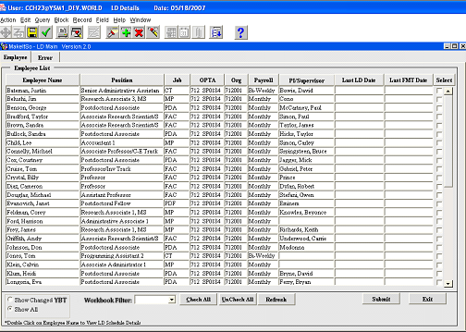
- To see detail for one employee, simply double click on the employee’s name. This will bring you to four detail screens. |  | 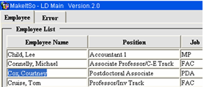
- The Proposed LD screen shows the employee’s information and then the proposed changes to LD at the Assignment and Earnings element levels. MIS will show lines that will be excluded from being sent to LD and give the reason in the Exclude Reason box.  You may also click to exclude a line. You may submit checked lines from this screen by clicking one of the three buttons at the bottom: All, Assignment Only or Element Only. |  | 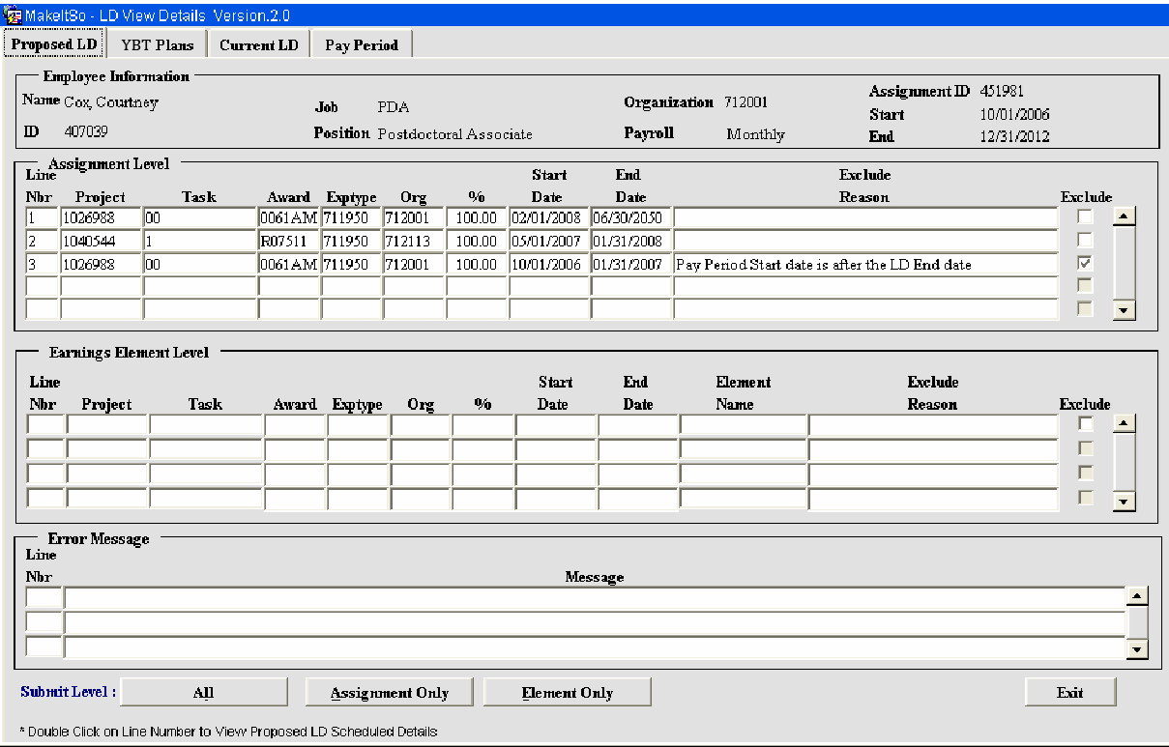
- If you double click on any line, you will see this detail box. |  | 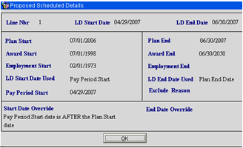
- The second tab, YBT Plans, shows the PTAEO lines for this employee as they currently appear in YBT. If these lines are not what you expect, check to be sure you had a complete save in YBT. |  | 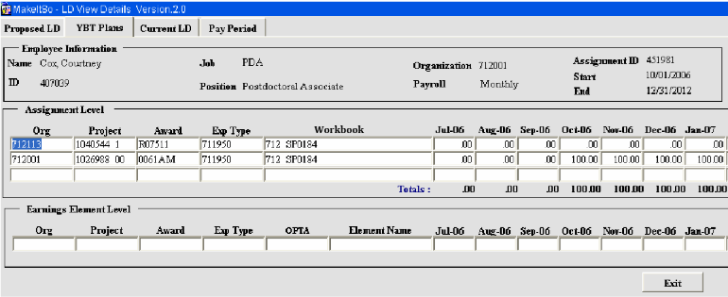
- The third tab, Current LD, shows the employee’s distribution currently in Oracle LD as a reference. Once you submit your changes in Make-It-So, you may return to this screen to see the changes in LD.  If you select the All button at the bottom of the screen, you will see historical data in LD for this employee. |  | 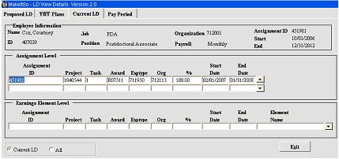
- Finally, as a reference, there is a tab to show the start and end dates of Pay Periods for the Employee in question. |  | 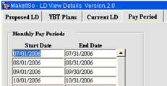

Make-It-So Myths
Make It So is a standalone application which takes the work you’ve completed in the YBT labor plan and pushes it to Labor Distribution (LD), saving you time and effort, as well as preventing duplication and text entry errors. YBT does not process labor distribution adjustments in this push to LD.

Myth #1 - You have to submit all changes from the labor plan.
- NOT True! - Manually check just the employees you want to submit in the column to the right. You may submit to LD from this screen by selecting Submit.
BUSTED! 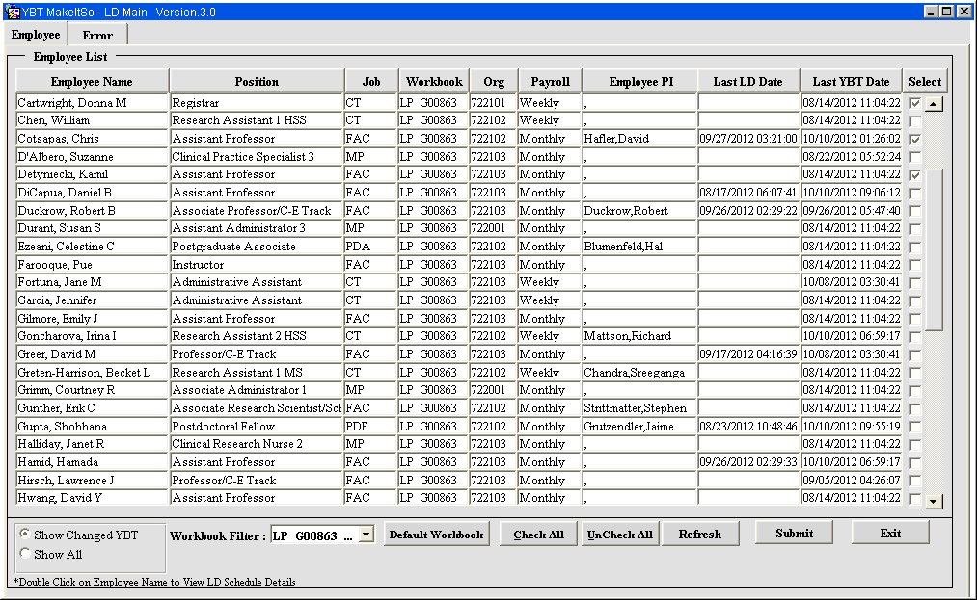

Myth #2 - There is a limit as to how many rows in labor schedule can be handled by MIS.

Answer: This was true, but has been fixed!

Myth #3 - Sometimes, the information does not transfer to Oracle from MIS

Answer: If a line is excluded from being sent to LD, the Exclude column is checked and a reason is stated in the reason column. NEED THIS CONFIRMED – Please comment

Myth # 4 - You need to open Oracle ensure labor schedules updated correctly via MIS.
- Not True! – Simply click the Current LD tab to view the updated LD information. You may need to click the Refresh button, if you had MIS open.
BUSTED!
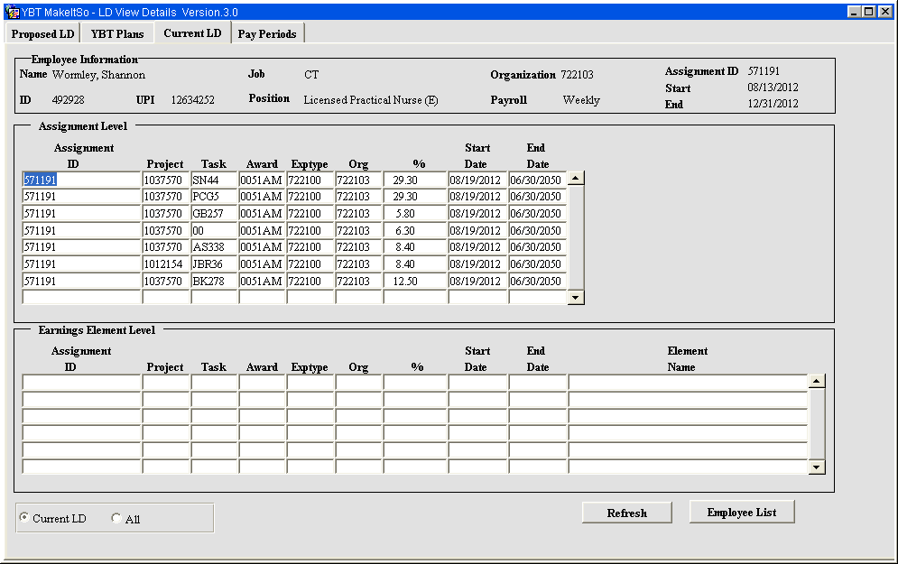

Myth # 5 - Individuals with mid month Start or End dates can’t be submitted via MIS
- Not True! – You can change the start date directly in MIS on the Proposed LD tab to accommodate this
BUSTED! 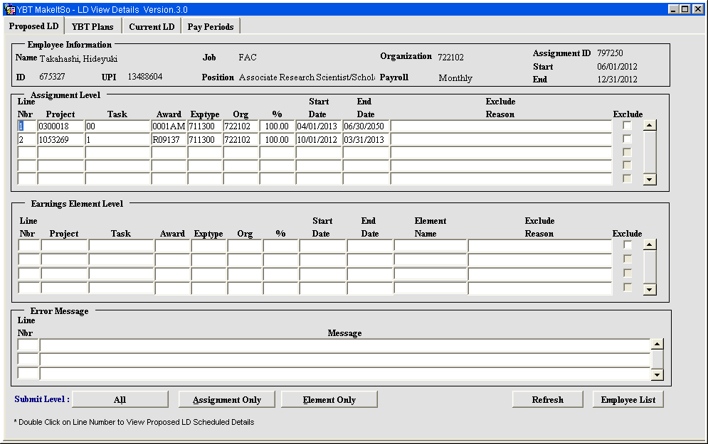
In the screen shot above, the date for the first line is 4/1/2012. In the screen shot below, the date is changed to accommodate the mid month start on March 15, 2012.
